Product Development Release Checklist
Aligned to Electrical PLC-Based Systems

Implementation Summary

Activity | Description | Responsibilities | Deliverables/Outputs
Complete ISO Product Release Checklist | The engineer must ensure all documentation required for product release is completed, reviewed, and filed. This includes technical specs, CE documentation, user manuals, electrical test procedures, BOMs, and curriculum content. Each section of the checklist must be verified as complete before final sign-off. | Design Engineer / Project Engineer | • All checklist items reviewed and completed  • Finalised documentation pack prepared for QA  • Compliance with internal release process confirmed  • Ready-for-release confirmation submitted to management

Description | Completed
Confirm that the engineer understands and follows the internal ISO-aligned release process.
Check that a responsible engineer has been assigned to complete and oversee the full product release checklist.
Verify that all sections of the checklist (specification, curriculum, CE file, user manual, test procedure, etc.) have been completed.
Confirm that any required technical drawings and electrical test procedures are included.
Ensure that all safety documentation (EN60204, CE declarations, LVD notes) is compiled and filed.
Verify that final documentation has been peer-reviewed or signed off by a senior engineer or QA lead.
Confirm that the final documentation pack is archived in the correct location on the NAS and version-controlled.
If certification is required (e.g. UKCA/CE), confirm that a compliance review has been requested.
Notes:
Approval for next step:
Actioned By: | Signature: | Position: | Date:
Verification By: | Signature: | Position: | Date:

Table of Contents
Product Development Release Checklist 1
Table of Contents 2
Process Overview 3
Project Checklist 4
Notes / Progress 6
Todo List 6
Brief Response 8
Specification 9
Curriculum – First Draft Completed 38
Electrical Drawings First Draft 40
PLC Software 41
Digital Curriculum 41

Process Overview
The intent of this process is not to overburden the engineer with tasks, but rather to serve as a way to track your own work. I think we can all agree the below work needs to be done. This document serves as a way to document the work we do across many months or years.
1. Brief Response Document
2. Specification Document
3. Curriculum Outline
4. Drawings First Draft
5. Software
6. Teacher’s Notes
7. User Manual
8. Electrical Wiring Diagrams
9. Hydraulic / P&ID Schematic
10. Electrical Test Procedures
11. Parts List
12. BOM
13. Packing List
14. CE Technical Documentation File
15. Wrap Up

Project Checklist
Task | Progress
1. Brief Response Document
Respond to the brief document by management for the proposal of a new project | Done
2. Specification Document
Define educational purpose (teaching dynamics of X...) | Done
Summarise learning outcomes (e.g., nine experiments, hands-on modules) | Done
Describe how the product functions in practice (flow feedback) | Done
Document system architecture (PLC, HMI, sensors, actuators) | Done
Provide a brief description of control logic overview | Done
Create a bullet list of 5–15 key features | Done
Write 5–8 learning objectives | Done
List all worksheet names | Done
Prepare curriculum front page | Done
Include images of main components | Done
Prepare buyer-orientated FAQ section | Done
Include 6–10 key practical and technical questions | Done
Ensure questions cover pre- and post-purchase topics | Done
Provide clear answers for each question | Done
Write tender specification (contractual promise) | Done
Define exact hardware features (tank size, materials, quick-release mounts) | Done
Define control and communication capabilities (HMI, USB, Wi-Fi, LAN) | Done
Specify performance expectations (real-time data, digital flow control) | Done
Include software features and update access | Done
Confirm number of components and experiments | Done
Add electrical safety information | Done
3. Curriculum Outline
Include 5–15 worksheets | Done
Add further reading / recommendations | Done
4. Electrical Drawings Draft
Create first draft of electrical drawings
5. Software
Write and test PLC code
Design HMI screens
Add and verify fault logic
Add and verify alarm logic
6. Teacher’s Notes
Align learning objectives with national/international standards (T-Level, NVQ, IEC 61131)
Outline teaching strategy (guided, fault-led, discovery-based)
Provide suggested delivery schedule and pacing
Include safety briefing
Include worksheet answers
7. User Manual
Specify voltage, current, power, IP rating, and other technical details
Write system overview and startup instructions
Include safety notices (electrical, mechanical, thermal)
Add operating procedures and system flow
Create HMI / screen manual
Add emergency procedures (E-stop, reset, fault recovery)
Write maintenance instructions and intervals
Create critical spares list
8. Electrical Wiring Diagrams
Create power distribution diagram
Create I/O, analogue, and actuator diagram
Create terminal block layout and labelling
Create network layout
Include grounding plan
Add electrical parts list
9. Hydraulic / P&ID Schematic
Draw pump intake and outlet
Include proportional valve control path
Mark flow sensor and manual valve locations
Indicate overflow route and shut-off points
10. Electrical Test Procedures
Create electrical test procedure document
Perform continuity checks for all field wiring
Verify power-up sequence and logic
Perform emergency stop dual channel test
Conduct input/output response test (digital and analogue)
Simulate and verify sensors
Test overload and short-circuit protection
Validate fail-safe behaviour
11. Parts List
Include component drawing reference
Include description, manufacturer, part number, quantity
Confirm CE/UL status
Include datasheet links or folder
Identify spare/replacement parts list
12. BOM
Create BOM with prices in Excel for management
13. Packing List
List Matrix part number, description, and quantity
14. CE Technical Documentation File
Include EU Declaration of Conformity
Add Product General Information
Include Hazard Analysis Report
Add Risk Assessment Process
Add full Risk Assessment
Include Essential Health & Safety Requirements
Include Control Systems section
Include Protection Against Mechanical Hazards
Include Guards & Protective Devices
Include Risks Due To Other Hazards
Include Maintenance section
Include Information, Instructions & Warnings
Add Technical Information
Add Technical Documentation Register
15. Wrap Up
Review all documents
Update any changes
Send BOM to mechanical engineer
Print CE label
Apply revision control to all documents
Upload all documents to NAS

Notes / Progress

New Layout
We’re adjusting sensor positioning to better optimise the factory.
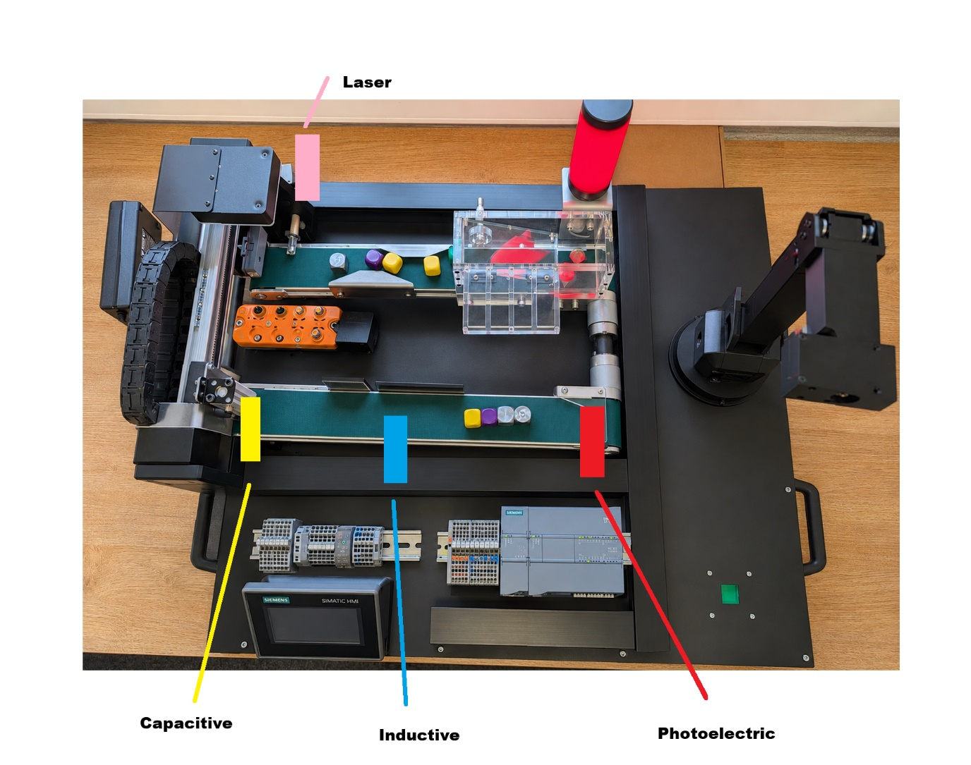

Todo List
- Fix bug where gantry isn’t homing
- Rewrite material detect code
- Add laser to IO-Link master
- Counter Analytics

My Progress
Task | % | Days Left
Primary
Electrical Drawings | 95% | 1
BOM / Parts List | 70% | 5
PLC Code | 40% | 10
HMI | 40% | 10
Robot Integration | 70% | 4
IO Link | 70% | 2
Camera Vision System | 70% | 5
Curriculum | 20% | 10
CE Documentation | 0% | 3
Interactive Curriculum | 0% | 1
Secondary
IIOT Analytics | 0% | 5
RFID | 0% | 3
Computer App | 80% | 1
Mobile App | 50% | 2
 |  | 62 Days

Brief Response
Brief Response rev 3 is complete.
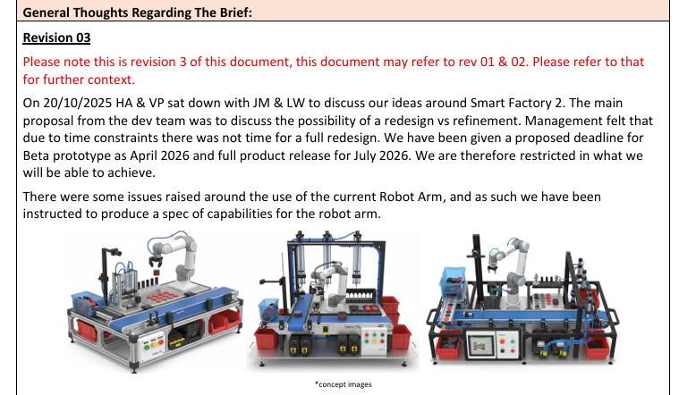

To Be Implemented | NOT To Be Implemented
- Hide tubing & wires under base  - Embed AU0205 onto Smart Factory  - Continuous Motion (Loop)  - Longer Gantry System 1 Access  - Siemens G2 PLC  - IO Link  - RFID Tagging  - MCB  - Estop  - 2 Conveyors  - Base Increase 700 x 700  - 3-6 Generic Zones  - Camera  - Simulated KPIs  - Simulated OEE | - X / Y Gantry System  - Digital Twin Simulation  - Sliding Arm on Linear Rail  - AI Edge  - Faults  - Data Logging  - AI Camera

Specification

Brief Description
The Smart Factory 2 system is designed to develop practical and theoretical understanding of modern manufacturing and Industry 4.0 technologies, aligning directly with BTEC Nationals Level 3 in Engineering units on Automation, PLCs, and the Industrial Internet of Things (IIoT). Learners gain experience of how real production systems are controlled, monitored, and optimised using PLCs, HMIs, and networked sensors within an automated manufacturing cell.
Students explore how DC motors, stepper drives, conveyors, and gantry systems form the mechanical foundation of an automated process, while pneumatic pick-and-place mechanisms demonstrate industrial handling and assembly. Through the integration of sensors, controllers, and visualisation tools, learners investigate how data is gathered, analysed, and used to improve production efficiency, product quality, and predictive maintenance.
The system introduces the core principles of Industry 4.0 such as interoperability, information transparency, decentralised control, and modularity, showing how smart factories connect people, machines, and digital systems through IIoT communication networks. IO-Link compatible sensors further enhance this by enabling intelligent, real-time communication between devices and the PLC, giving students practical insight into modern industrial networking. With optional RFID and vision add-ons, data logging, and web-based control, Smart Factory 2 provides a complete educational platform for teaching connected, data-driven manufacturing practices.

Target Audience
The Smart Factory 2 curriculum is designed for students aged 16–19 studying engineering, automation, or mechatronics in further and higher education. It is ideally suited to learners enrolled on T-Level, BTEC, and HNC/HND engineering programmes, as well as apprentices beginning careers in industrial automation, manufacturing, and process control.
The program is also suitable for vocational training centres and universities seeking hands-on exposure to Industry 4.0 technologies, including PLC and HMI programming, pneumatic control, robotics, and data-driven maintenance. By engaging with real industrial hardware and live fault scenarios, students develop essential skills in system design, troubleshooting, and digital manufacturing operations, preparing them for modern roles across automotive, utilities, logistics, and advanced manufacturing sectors.

Learning Outcomes
- Factory control and automation systems
- Software design for automation
- DC motor and stepper drives
- Conveyor and gantry systems
- Vacuum pick and place systems
- Component sensing and sorting
- System design with more than one controller (some systems)
- Data collection and visualisation for process monitoring
- Networked communication between PLCs, HMIs, and robots
- Predictive maintenance using live system data
- Integration of modular add-ons such as RFID and vision systems
- Web or mobile-based control and monitoring interfaces

Product Functionality

Current Smart Factory v1
Start Up > Gantry collects counter > Gantry drops counter onto conveyor > Conveyor transports counter through sensor module > Sensors detect if counter is steel, aluminium or plastic > paddle reject mechanisms sort aluminium and steel into separate bins > robot arm collects plastic counter > robot arm shows plastic counter to colour sensor > robot arm sorts counter into bins based on counter colour
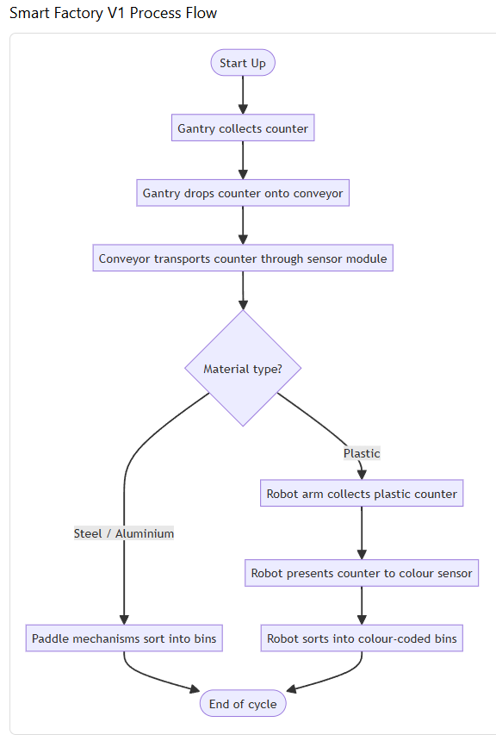

Current Layout;
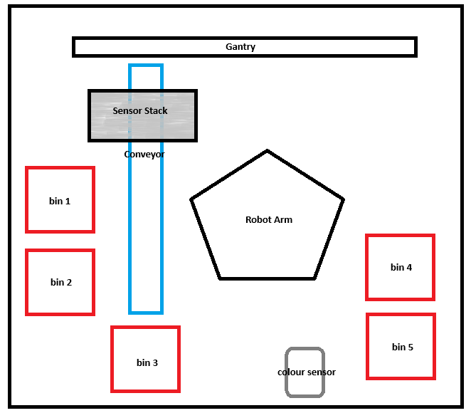

Smart Factory 2 Process Ideas
- Recycling and materials recovery line – Sort metals vs plastics with inductive/capacitive sensors, then colour-sort plastics.
- Plastic reprocessing / pellet or cap sorting – Colour classification of plastics into white vs black streams using the colour sensor.
- Small-parts sorting (manufacturing QA) – Separate aluminium vs steel components, reject to different bins; treat colour as grade/finish.
- Food and produce grading demo (abstracted) – Use material sensors as stand-ins for quality gates, then colour step for ripeness/grade.
Some other ideas are;
- Parcel sorting centre
- Grain or coffee bean size-sorting plant
- Pharmaceutical pill sorting or counting line
- Electronics component sorting line
- Automotive parts inspection and sorting cell
- Textile colour or material sorting line
- Mining and mineral sorting plant
- Waste management sorting station
- Glass and metal feed sorting line
- Airport baggage sorting system
- Quality grading and reject handling cell

Recycling
Recycling seems most suitable with what we currently have.
- → Hopper holds mixed material
- → Gantry picks and places counters from the hopper onto the conveyor
- → Conveyor moves items through the sensor module
- → Sensors identify material type (steel, aluminium, plastic)
- → PLC activates paddle mechanisms to sort metals into bins
- → Plastic counters continue to the robot station
- → Robot arm colour-sorts plastics into correct bins
- → System performance and sorting data logged to HMI/IIoT dashboard for analysis.
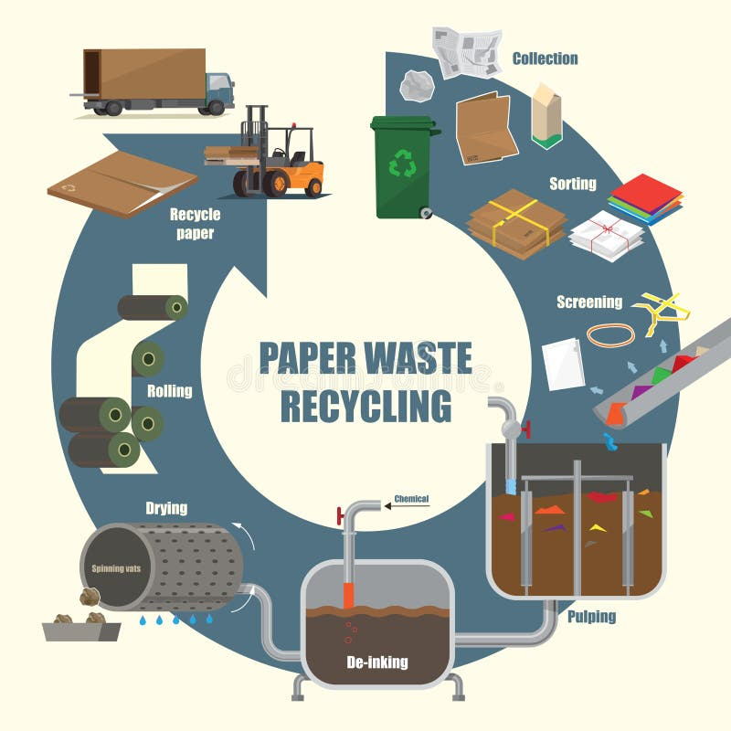

Proposed Process
- Hopper has mixed material (cubes)
- Conveyor runs and cubes travel down the conveyor until the sensor at the end of the conveyor detects a cube and stops the conveyor.
- The camera then looks at the cube, checks its colour and checks for defects.
- If defect found, the reject mechanism knocks the cube off the conveyor into a defect bin.
- If no defect, the gantry carries the cube from the first conveyor to the second conveyor.
- The second conveyor runs and moves the cube past the two sensors, to check if its steel or aluminium.
- A final sensor at the end of conveyor 2, stops the conveyor when the cube is at the end of conveyor.
- The robot arm then grabs the cube and sorts it into one of 4 bays based on whether the cube is steel, aluminium, plastic purple or plastic yellow.
- Upon completion of all cube processing, the sorted bay is cleared into the hopper using the linear actuator to tip the sorted bay into the hopper.
- Ready for next cycle.
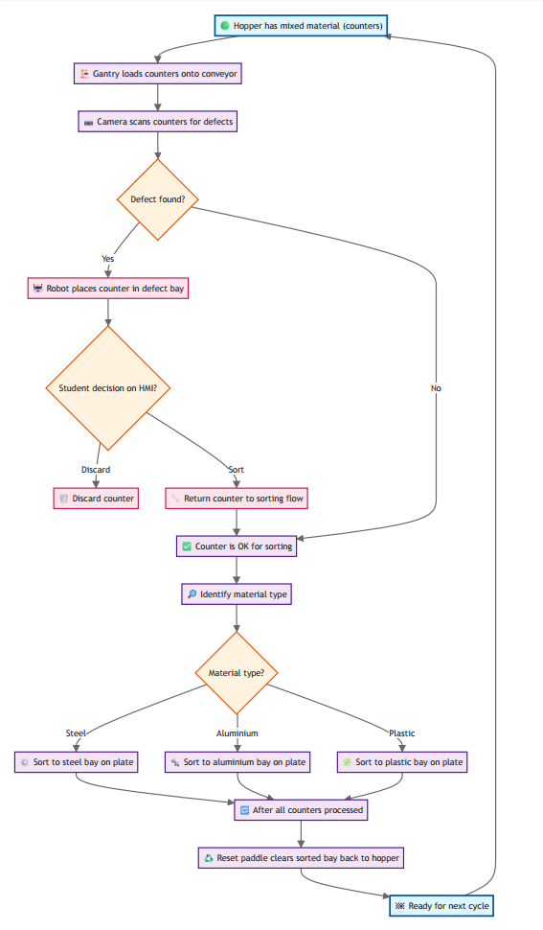

Proposed Layout
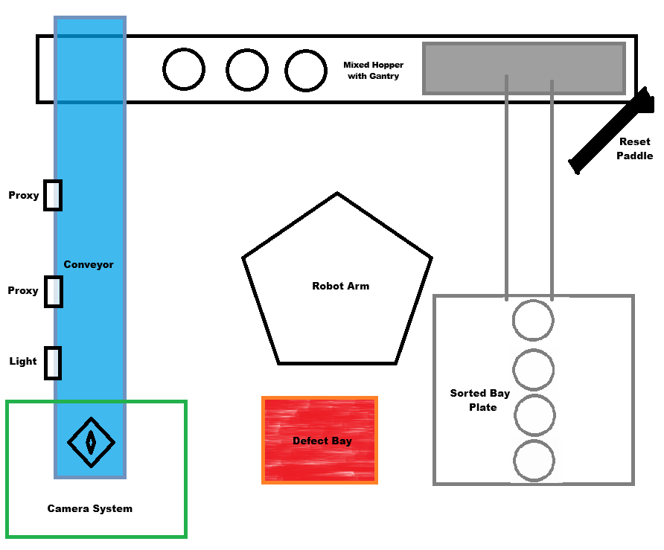

System Architecture
- Control Layer: Real-time logic, sequencing, and safety
- Edge Layer: Vision processing and data handling
- Robotics Layer: Physical movement and actuation
- Sensor Layer: sensor data (maybe add load cell)
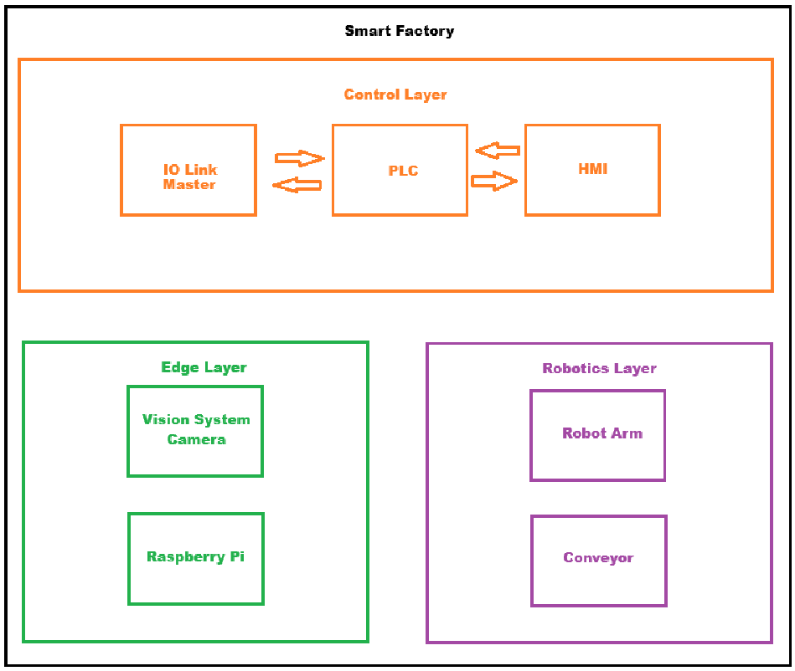

System Hardware & Design
- Siemens S7-1200 PLC providing digital and analogue I/O for complete process control.
- Siemens 7-inch Unified Basic HMI for real-time monitoring, control, and system diagnostics.
- 24 V DC conveyor drive with PWM speed control for accurate material transport.
- Stepper-driven gantry system with vacuum plunger for automated pick-and-place operations.
- Inductive, capacitive, and photoelectric sensors for material detection and sorting.
- Pneumatic manifold with 3/2 and 5/2 solenoid valves for plunger and reject mechanisms.
- IO-Link Master and smart sensors enabling plug-and-play connectivity and advanced diagnostics.
- Raspberry Pi edge processor for vision system integration and data handling.
- Modular steel and aluminium base, compact and durable for classroom or lab use.
- CE/UL compliant components and wiring, incorporating internal fusing, circuit isolation, and safe 24 V DC operation.

Control Logic Overview

Short Description of Logic
The system starts with mixed counters in a hopper. A gantry loads counters onto a conveyor. A camera scans each counter for defects. If a defect is detected, a robot places the counter in a defect bay for student investigation on the HMI. The student can discard the item or approve it to return to sorting. Approved or non-defective counters are identified by material type and directed into the matching bay on a sorting plate (steel, aluminium, plastic). When all counters in the batch are processed, the reset paddle clears the bays back into the hopper, ready for the next cycle.

Overview of Logic
Main PLC Logic Flow – Smart Factory 2
- System Start-Up
  - PLC checks emergency stop, air pressure, home sensors
  - Confirms robot, gantry, and reset paddle are in safe positions
  - Sends “System Ready” to HMI
  - HMI enables Start button
- Batch Start
  - HMI start command received
  - PLC begins automatic cycle
  - HMI displays Cycle Running
- Loading (Gantry)
  - Gantry moves to hopper
  - Vacuum tool picks counter
  - Gantry moves to conveyor and releases counter
  - Sensor confirms counter on conveyor
  - Conveyor starts
- Inspection (Camera via Raspberry Pi)
  - Conveyor stops at inspection point
  - PLC sends camera trigger signal to Raspberry Pi
  - Raspberry Pi captures image from camera
  - Raspberry Pi runs the always-on YOLO model to classify the cube (yellow / purple / metal) and check for defects
  - Pi sends result to PLC via Ethernet (Snap7 over the 192.168.7.x Ethernet network)
  - PLC waits for valid result or uses proxy sensors if timeout
  - PLC sends inspection data to HMI for display
- Defect Handling
  - If defect found → PLC instructs robot to move part to defect bay
  - HMI shows defect image and options (Discard / Approve)
  - PLC waits for student decision from HMI
  - Student input determines next action (discard or return to sorting)
- Sorting (Robot)
  - For good or approved parts → PLC commands robot to sort by material
  - Robot places counter in correct bay (steel, aluminium, plastic)
  - Robot signals completion
  - PLC updates count and restarts loading
- Batch Completion
  - All counters processed
  - PLC signals Batch Complete to HMI
  - HMI prompts student to run reset cycle
- Reset (Paddle)
  - Student starts reset from HMI
  - PLC stops motion and activates reset paddle
  - Paddle clears sorting bays into hopper
  - PLC signals Cycle Finished to HMI
  - System returns to idle
- Communication Summary
  - Camera → Raspberry Pi: image data
  - Raspberry Pi → PLC: colour class (yellow / purple / metal) and defect flag over Ethernet (Snap7)
  - PLC ↔ HMI: status, control commands, student decisions
  - PLC ↔ Robot, Gantry, Sensors: 24 V digital I/O control and feedback

Detailed Breakdown of Logic

1) Scope and assumptions
- One part at a time on the inspection zone. FIFO otherwise.
- PLC is master. Camera and robot use handshake bits. Gantry and paddles are digital I/O.
- Materials: steel, aluminium, plastic. Defect is separate from material class.
- HMI provides start, stop, defect decision, and manual jogs.

2) I/O list and tag naming
Use this style: I_ inputs, Q_ outputs, M_ internal, DB. structured data, T_ timers.
Digital inputs
- I_StartPB, I_StopPB, I_EStopOK
- I_Gantry_Home, I_Gantry_Pos_Conv, I_Gantry_Vac_OK
- I_PE_Load light gate at hopper pickup
- I_PE_CamIn, I_PE_CamOut light gates bracketing camera
- I_DefectBay_Empty
- I_ResetPaddle_Home, I_ResetPaddle_Ext
- I_Robot_Ready, I_Robot_Busy, I_Robot_Fault
- I_Cam_Ready, I_Cam_Busy
- Material sensors:
- I_Inductive, I_Capacitive
Digital outputs
- Q_Conv_Run
- Q_Gantry_ToConv, Q_Gantry_Pick, Q_Gantry_VacOn
- Q_Cam_Trigger
- Q_Robot_Req plus job bits: Q_Robot_Job_SortSteel, ...Al, ...Plastic, Q_Robot_Job_Defect
- Q_ResetPaddle_Ext
- Beacons: Q_Stack_Red, Q_Stack_Amber, Q_Stack_Green
Camera result interface (from vision or via PLC comms)
- I_Cam_Result_Valid
- I_Cam_Result_Defect (1 means defective)
- I_Cam_Result_Class[0..2] one-hot from the camera: yellow, purple, metal. These are the camera's colour/appearance classes; steel vs aluminium is resolved by the inductive and capacitive sensors on the second conveyor, not by the camera.
- I_Cam_PartID optional integer for tracking
HMI tags
- Commands: HMI_Start, HMI_Stop, HMI_Auto, HMI_Manual, HMI_Reset, HMI_AckFault
- Defect decision for last part: HMI_DefectDecision enum {Discard, Reclassify, Keep}
- Reclassify target: HMI_Reclass enum {Steel, Aluminium, Plastic}
- Timers setpoints: SP_Conv_Settle_ms, SP_Cam_Expose_ms, SP_Robot_Timeout_ms, etc.

3) Top level states (SFC or state machine)
Machine_State:
- Idle
- Precheck safety and device ready
- LoadPart gantry pick and place to conveyor
- ToInspect move part to camera infeed
- Inspect trigger camera, wait result
- DefectDecision branch by result and student choice
- RobotSort request robot job and wait complete
- CompleteCheck next part or cycle end
- ResetSorted actuate reset paddle to dump bays to hopper
- Fault latched until cleared
Transitions
- Idle → Precheck on Start.
- Precheck → LoadPart when all interlocks true.
- LoadPart → ToInspect when gantry at conv position and PE confirms part on belt.
- ToInspect → Inspect when I_PE_CamIn goes high then belt stops with part in window.
- Inspect → DefectDecision when I_Cam_Result_Valid.
- DefectDecision → RobotSort with job resolved.
- RobotSort → CompleteCheck when robot done.
- CompleteCheck → LoadPart if hopper not empty, else → ResetSorted if batch done and ResetMode=Auto, else → Idle.
- Any state → Fault on safety or device error.

4) Interlocks and safety
- I_EStopOK must be true to run.
- Q_Conv_Run inhibited when I_Robot_Busy=1 and part is within robot work envelope.
- Gantry moves only when robot not over gantry lane.
- Reset paddle cannot extend unless robot idle and conveyor stopped.
- Camera trigger only when Q_Conv_Run=0 and part is within window between I_PE_CamIn and I_PE_CamOut.

5) Detailed sequence per part
A) LoadPart
- Preconditions: I_Gantry_Home=1, I_Robot_Busy=0.
- Steps:
  - Q_Gantry_ToConv=1 move to hopper, pick sequence: Q_Gantry_Pick=1, Q_Gantry_VacOn=1, confirm I_Gantry_Vac_OK=1.
  - Move to conveyor drop position I_Gantry_Pos_Conv=1, then Q_Gantry_Pick=0 to lower, Q_Gantry_VacOn=0 release.
  - Verify I_PE_Load=1 then I_PE_Load=0 as belt starts.
B) ToInspect
- Start belt Q_Conv_Run=1 until I_PE_CamIn=1.
- Stop belt with a small delay for centering SP_Conv_Settle_ms.
C) Inspect
- Check I_Cam_Ready=1. Pulse Q_Cam_Trigger for SP_Cam_Expose_ms.
- Wait I_Cam_Result_Valid=1. Read Defect and Class[]. Timeout to Fault if no result.
D) DefectDecision
- If Defect=1: place in defect bay now.
  - Issue robot job Defect.
  - Also raise HMI card with image and decision. After robot places, student decides:
    - Discard: leave in defect bay or robot moves to discard chute.
    - Keep or Reclassify: enqueue a second robot job to target bay.
- If Defect=0: job equals class bay.
E) RobotSort
- Preconditions: I_Robot_Ready=1.
- Set only one job bit high, then Q_Robot_Req=1.
- Wait I_Robot_Busy rising then falling.
- Clear job and request. Timeout goes to Fault.
F) CompleteCheck
- Resume belt Q_Conv_Run=1 to clear inspection zone until I_PE_CamOut toggles.
- Counted part increments KPIs.

6) Reset cycle
- When BatchDone=1 or HMI_ResetSorted=1:
  - Ensure Q_Conv_Run=0, robot idle.
  - Extend paddle: Q_ResetPaddle_Ext=1 until I_ResetPaddle_Ext=1. Dwell.
  - Retract until I_ResetPaddle_Home=1.
  - Set BatchDone=0.

7) Faults and alarms
- Categories: Safety, Device not ready, Timeout, Sensor disagreement, Jam.
- Typical faults and latches:
  - F_EStop when I_EStopOK=0.
  - F_CamTimeout no I_Cam_Result_Valid within SP_Cam_Timeout_ms.
  - F_RobotTimeout job not finished in SP_Robot_Timeout_ms.
  - F_GantryVac expected I_Gantry_Vac_OK=0/1 not reached.
  - F_Jam I_PE_CamIn held high too long.
- On any Fault: stop conveyor, de-energise movements, set Q_Stack_Red=1, require HMI_AckFault then controlled return to Idle.

8) HMI functions
- Auto, Manual, Jog for Gantry, Conveyor, Paddle.
- Live part card: thumbnail from camera, class, defect flag, HMI_DefectDecision.
- Batch controls: target count, current count, Reset sorted.
- Alarm banner with help text and recovery steps.
- Settings page for timer setpoints and enable material sensors fallback.

9) Timers and setpoints
- SP_Conv_Settle_ms 150 to 300
- SP_Cam_Expose_ms 20 to 80 (as required by vision)
- SP_Cam_Timeout_ms 1500
- SP_Robot_Timeout_ms 6000 to 10000
- SP_Paddle_Dwell_ms 500
- SP_Gantry_Pick_Dwell_ms 200

10) Data, KPIs, trace
- DB_Prod per cycle log: timestamp, PartID, Class, Defect, Decision, RobotJob, CycleTime_ms.
- KPIs: cycle time, FPY, defect rate, robot utilisation, jams.
- Optional SQL/logger task for export.

11) Robot handshake detail
- PLC sets one job bit only and Q_Robot_Req=1.
- Robot responds by raising I_Robot_Busy=1.
- On job complete robot drops I_Robot_Busy=0 and pulses I_Robot_Ready=1.
- PLC then clears job and request. If I_Robot_Fault=1 raise fault and show robot code.

12) Camera handshake detail
- I_Cam_Ready=1 confirms idle.
- PLC pulses Q_Cam_Trigger.
- Camera sets I_Cam_Busy=1 during processing, then I_Cam_Result_Valid=1 with stable result bits for at least 2 scans.
- PLC latches result into DB_LastResult and commands next step.
- If I_Cam_Result_Valid never sets within timeout, fault.

Pseudo Code
CASE M_State OF
Idle:
IF HMI_Start AND I_EStopOK THEN
M_State := Precheck;
END_IF;

Precheck:
IF I_Robot_Ready AND I_Cam_Ready AND I_Gantry_Home THEN
M_State := LoadPart;
END_IF;

LoadPart:
Gantry_PickFromHopper(); // controls Q_Gantry_* and checks I_Gantry_Vac_OK
Gantry_DropToConveyor();
IF PartOnBelt() THEN
M_State := ToInspect;
END_IF;

ToInspect:
Q_Conv_Run := TRUE;
IF RisingEdge(I_PE_CamIn) THEN
StartTimer(T_ConvSettle, SP_Conv_Settle_ms);
Q_Conv_Run := FALSE;
IF T_ConvSettle.Q THEN
M_State := Inspect;
END_IF;
END_IF;

Inspect:
// Primary inspection by camera, with proxy sensor fallback
IF I_Cam_Ready THEN
Pulse(Q_Cam_Trigger, SP_Cam_Expose_ms);
StartTimer(T_CamTO, SP_Cam_Timeout_ms);

// Wait for valid camera result or fallback timeout
IF I_Cam_Result_Valid THEN
DB_LastResult := ReadCameraResult();
M_State := DefectDecision;

ELSIF T_CamTO.Q THEN
// Camera failed → use proxy sensors instead
DB_LastResult.Defect := FALSE; // proxies can’t detect defects
IF I_Inductive THEN
DB_LastResult.Class := "Steel";
ELSIF I_Capacitive THEN
DB_LastResult.Class := "Aluminium";
ELSE
DB_LastResult.Class := "Plastic";
END_IF;
M_State := DefectDecision;
END_IF;
END_IF;

DefectDecision:
// Combine camera and proxy info for redundancy
IF DB_LastResult.Defect THEN
JobOut := "Defect";
ELSE
// Cross-check proxy readings to verify camera classification
IF I_Inductive THEN
VerifiedClass := "Steel";
ELSIF I_Capacitive THEN
VerifiedClass := "Aluminium";
ELSE
VerifiedClass := "Plastic";
END_IF;

// If mismatch, flag a warning for HMI display
IF VerifiedClass <> DB_LastResult.Class THEN
M_Warning_SensorMismatch := TRUE;
END_IF;

// Select robot job based on verified material
CASE VerifiedClass OF
"Steel": JobOut := "SortSteel";
"Aluminium": JobOut := "SortAluminium";
"Plastic": JobOut := "SortPlastic";
END_CASE;
END_IF;

M_State := RobotSort;

RobotSort:
IF RequestRobot(JobOut) THEN
StartTimer(T_RobotTO, SP_Robot_Timeout_ms);
IF NOT I_Robot_Busy AND I_Robot_Ready THEN
M_State := CompleteCheck;
ELSIF T_RobotTO.Q OR I_Robot_Fault THEN
FaultCode := F_RobotTimeout;
M_State := Fault;
END_IF;
END_IF;

CompleteCheck:
RunConveyorUntilClear();
UpdateKPIs();
IF BatchDone THEN
IF AutoReset THEN
M_State := ResetSorted;
ELSE
M_State := Idle;
END_IF;
ELSE
M_State := LoadPart;
END_IF;

ResetSorted:
DoResetPaddleCycle();
M_State := Idle;

Fault:
Q_Conv_Run := FALSE;
StopAllMotion();
IF HMI_AckFault AND FaultCleared() THEN
M_State := Idle;
END_IF;
END_CASE;

Key Features
- Closed-loop process: Automatic cycle ending with bay reset back to hopper.
- Gantry loading: Simple and reliable counter placement onto the conveyor.
- Vision inspection: Camera-based defect detection with configurable thresholds.
- HMI student decision: Approve-or-discard workflow for flagged counters.
- Robotic sorting: Placement into steel, aluminium, or plastic bays.
- Material identification: Deterministic routing by material type.
- Batch completion logic: Automatic transition to reset once items are processed.
- Cycle-ready reset: Paddle returns all sorted parts to hopper for next run.
- Data capture: Optional logging of decisions, defects, and throughput.
- Safety interlocks: E-stop and guarded motion zones.

Learning Objectives
- Describe how PLCs, HMIs, sensors, and actuators work together in an automated control system.
- Write and test simple PLC programs to control motors, conveyors, and pneumatic devices.
- Configure and tune DC motor and stepper drives for precise motion control.
- Build and operate a conveyor and gantry sequence to move and sort components.
- Set up a vacuum pick-and-place system and explain its pneumatic operation.
- Use inductive, capacitive, and optical sensors to detect and sort different materials.
- Create a multi-controller setup where a robot, PLC, and HMI exchange control signals.
- Record live data from the Smart Factory and plot it on an HMI or dashboard.
- Establish communication between devices using Ethernet, Modbus, or TCP/IP.
- Monitor system parameters and identify early signs of faults or maintenance needs.
- Integrate add-on modules such as RFID readers or vision cameras into the control system.
- Develop a basic web or mobile interface to monitor and control Smart Factory operations remotely.

Worksheets

Smart Factory 1
The worksheets from Smart Factory 1 are;
- Worksheet 1 - Understanding sensors (Page 4)
- Worksheet 2 - Reject mechanisms (Page 7)
- Worksheet 3 - Understanding the conveyor (Page 8)
- Worksheet 4 - Sorting counters (Page 10)
- Worksheet 5 - Driving the stepper motor (Page 13)
- Worksheet 6 - Understanding the plunger (Page 15)
- Worksheet 7 - Delivering counters (Page 16)
- Worksheet 8 - commissioning the cell (Page 21)
- Worksheet 9 - completing the smart factory (Page 23)

Smart Factory 2
Smart Factory 2 worksheets will be;
Smart Factory 1 (Original Worksheets)
1. Understanding sensors
2. Reject mechanisms
3. Understanding the conveyor
4. Sorting counters
5. Driving the stepper motor
6. Understanding the plunger
7. Delivering counters
8. Commissioning the cell
9. Completing the smart factory

Smart Factory 2 (New Worksheets)
Worksheet 1 – Understanding Sensors
Worksheet 2 – Reject Mechanisms
Worksheet 3 – Understanding the Conveyor
Worksheet 4 – Sorting Counters
Worksheet 5 –Driving the Stepper Motor
Worksheet 6 – Understanding the Plunger
Worksheet 7 – Delivering Counters
Worksheet 8 – Commissioning The Cell
Worksheet 9 – Completing the Smart Factory
Worksheet 10 – Reset Sequence
Worksheet 11 – Defects & Reset Sequence
Worksheet 12 – Vision System
Worksheet 13 – RFID
Worksheet 14 – Network & Communications
Worksheet 15 – Data Logging
Worksheet 16 – Analytics
Worksheet 17 – IO Link
Worksheet 18 – Predictive Maintenance

Curriculum Front Page
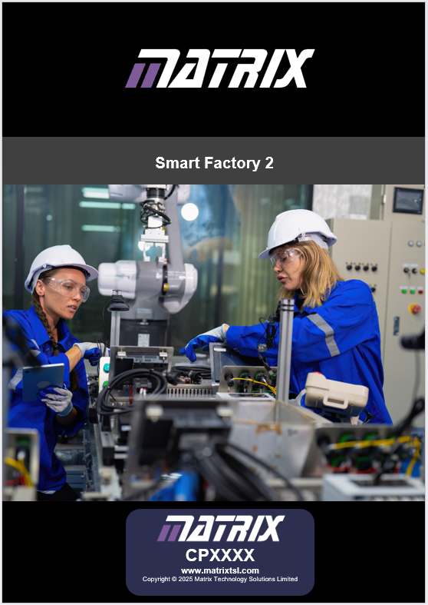

Main Components
We will be using the following industrial automation hardware;
- PLC
- 7 inch HMI
- IO Link Master
- Raspberry Pi
- IO Link Proxy 2x (1 capacitive 1 inductive)
- IO Link Photoelectric Sensor
- Camera (possibly industrial, more likely a cheap raspberry pi camera)

PLC – Siemens S7-1200 (CPU 1214C)  - Purpose: Central controller for logic, PID control, safety interlocks, and I/O processing  - Key Features:  - 14x Digital Inputs, 10x Digital Outputs (24VDC)  - 2x Analog Inputs (0–10V)  - Handles PID algorithm for flow regulation.  - Interfaces with HMI for setpoint, alarms, and diagnostics | 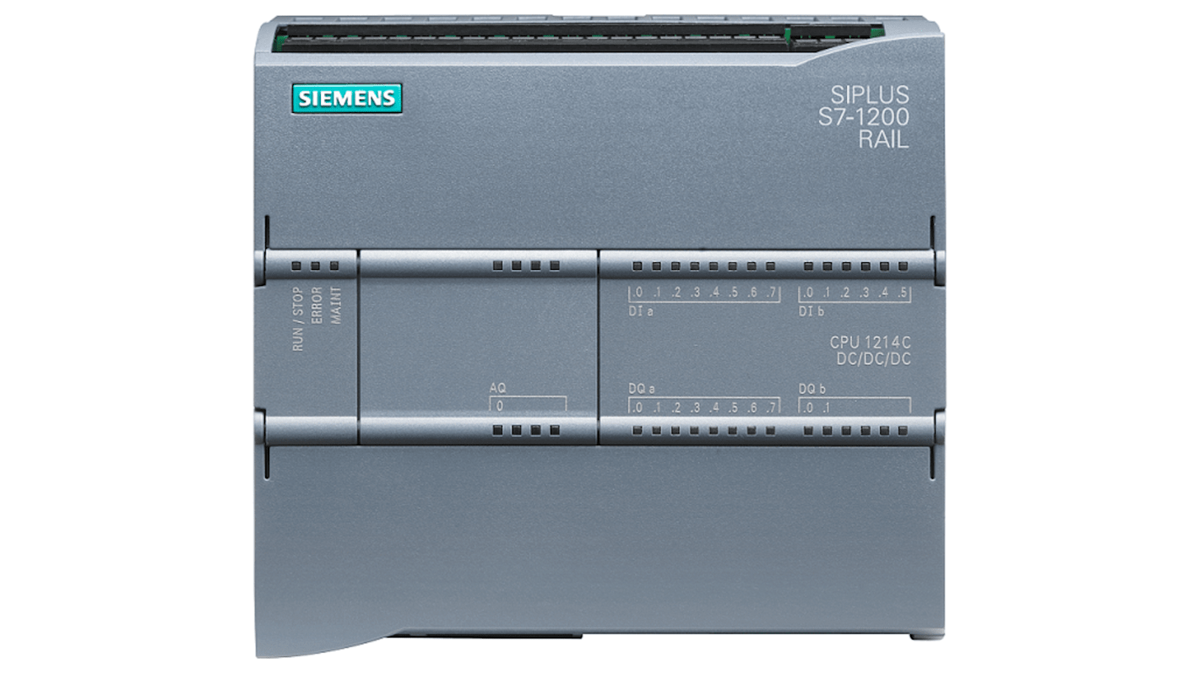
IO-Link Master Module (ifm AL1350)  - Purpose: Acts as the communication gateway between the PLC and multiple IO-Link sensors or actuators, enabling advanced data exchange and device parameterisation.  - Key Features:  - Connects up to 8 IO-Link sensors or actuators via M12 ports  - Transfers detailed sensor data and diagnostics to the PLC  - Enables fast setup and automatic device parameter loading  - Provides real-time process monitoring of sensor health and status  - Integrates with the Raspberry Pi for extended data logging and analysis  - Supports both standard digital I/O and IO-Link communication on each port  - Simplifies wiring by combining power and data through a single cable | 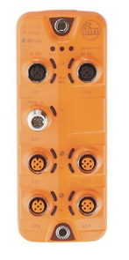
Unified HMI – Siemens Unified Basic Panel (MTP700)  - Purpose: Operator interface for real-time monitoring, fault display, and parameter input  - Key Features:  - 7" touch screen for user control of Smart Factory  - Displays alarms, I/O status  - Setup page allows editing of temperature cutout limits and viewing system state | 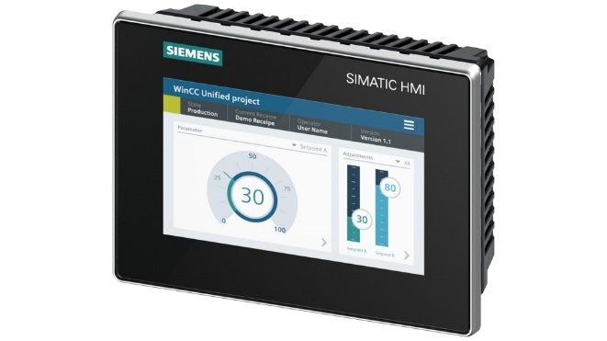
Edge – Raspberry Pi 5 8GB  - Purpose: Serves as the local processing and communication hub for vision, data logging, and networked control tasks within the Smart Factory.  - Key Features:  - Processes live camera images for part and defect detection  - Communicates inspection results to the PLC via Ethernet  - Logs production data such as cycle time and reject count  - Hosts local web dashboard for live monitoring and control  - Interfaces with IO-Link master for advanced sensor data  - Enables predictive maintenance and KPI tracking  - Acts as Industry 4.0 gateway for data exchange and visualisation | 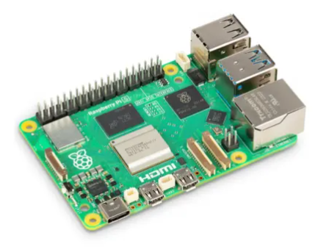
Capacitive Sensor – RS PRO M18, 8 mm Detection, IO-Link  - Purpose: Detects non-metallic and metallic counters on the conveyor to distinguish between material types.  - Key Features:  - Inductive sensor with 16 mm sensing distance, ideal for general object detection | 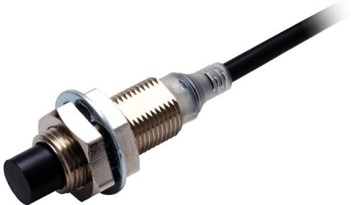
Proximity Sensor – Omron E2E-X16MB1T12 2M (Inductive, M12, PNP, NO)  - Purpose: Detects both metallic counters (steel and aluminium) to distinguish them from non-metallic materials such as plastic.  - Key Features:  - Differentiates metal counters from plastic for multi-stage material sorting  - Works alongside the inductive sensor to separate steel from aluminium and plastic  - Adjustable sensitivity allows fine-tuning for reliable detection of various materials  - IO-Link connectivity provides live status, signal quality, and diagnostic feedback to the PLC  - Integrates with the Raspberry Pi for extended monitoring and data logging | 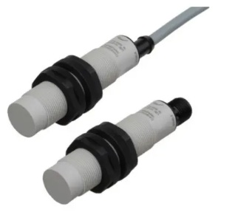
Photoelectric Sensor – Banner Background Suppression (IO-Link, 30–250 mm)  - Purpose: Detects the presence and position of objects on the conveyor without being affected by background surfaces or lighting conditions.  - Key Features:  - Provides precise detection of counters on the moving conveyor without interference from background reflections  - Communicates detection status and diagnostic data to the PLC via the IO-Link master  - Adjustable sensing range allows tuning for different counter materials and colours  - Supports consistent part detection for reliable reject and sorting operations  - Enables live monitoring and parameter adjustments through the Raspberry Pi or HMI | 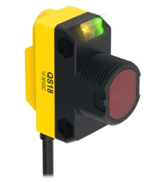
Status Indicator – Banner CL50 Multi-Colour LED Beacon  - Purpose: Provides a clear, visible indication of system state during training. The beacon changes colour to reflect normal operation, fault conditions, or emergency stop activation, allowing learners to quickly interpret system status at a glance.  - Key Features:  - Sealed RGB LED beacon with full-surface illumination for high visibility  - Displays green for normal operation, yellow for faults, and red for emergency stop or system lockout  - IO-Link capable model available, allowing advanced diagnostics, parameter control, and integration into Industry 4.0-ready systems  - IP67/IP69 protection rating, robust housing for industrial-style durability  - Operates from 18–30 V DC, directly driven by PLC outputs for real-time indication | 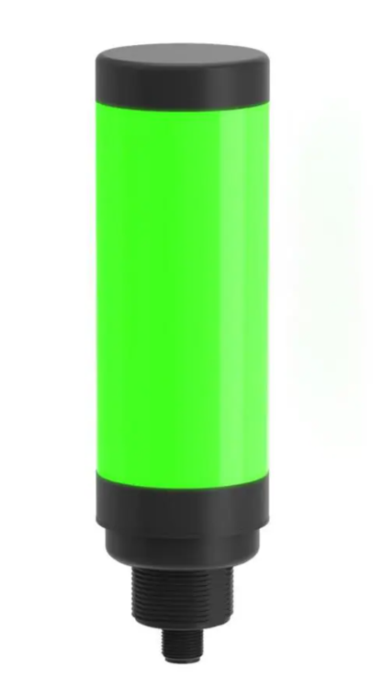
Emergency Stop – Siemens SIRIUS ACT, dual-channel, twist-release  - Purpose: Provides a rapid stop function for training use. Two NC channels feed the PLC; when pressed, the PLC immediately disables outputs, raises a safety fault on the HMI, and requires a manual reset before operation can resume.  - Key Features:  - Dual NC contact modules wired to separate PLC inputs for channel monitoring and fault detection | 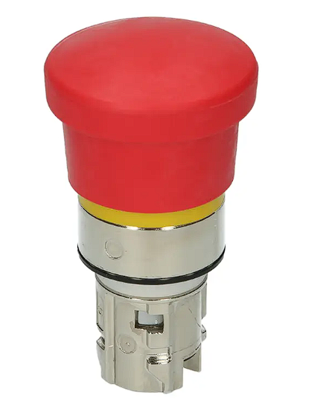
Relay – WAGO Interface Relay, DIN Rail Mount, 24 V AC/DC Coil, 1-Pole  - Purpose: Relay – WAGO Interface Relay, DIN Rail Mount, 24 V AC/DC Coil, 1-Pole (857-358)  - Key Features:  - 24 V AC/DC coil, compatible with standard PLC output voltage  - 1-pole changeover (SPDT) contact rated up to 250 V AC / 6 A  - Includes integrated status indicator for visual feedback | 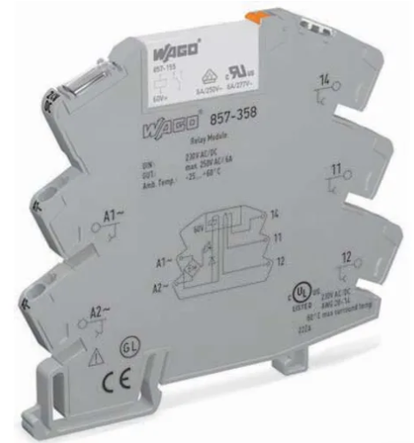

FAQ Section
Prepare Buyer-Orientated FAQ Section
What software is needed to run the system?
None. The system runs entirely self-contained using the onboard Siemens PLC and Unified HMI.
Optionally, Siemens TIA Portal (v20 and above recommended) can be used to modify or create your own PLC logic.
There is also an additional web app available via the product’s onboard web server. This can be accessed by typing in the products IP address; 192.168.7.1.
Does the kit come with curriculum materials?
Yes. A full curriculum is included, complete with guided student worksheets and detailed teacher notes, available through the Matrix Learning Centre.
What age group is this kit aimed at?
It’s designed for further and higher education students aged 16–20 studying engineering, automation, or maintenance.
How many students can use the kit at once?
It’s ideal for 2-4 students working collaboratively. Two learners can comfortably work side-by-side during practical sessions.
How is the system powered?
The system uses a 24V DC power supply and comes with UK, EU, and US adapters. No mains wiring is required.
The included air compressor is powered separately via a standard mains connection using a 3-pin plug.
Does the system need mains water or drainage?
No. The system operates using a pneumatic air compressor, no external plumbing is required.
To run the system, simply connect and power the air compressor.
Can other compressors be used with the system?
It is not recommended. The system is designed to operate with the specific mains-powered compressor supplied. Using a different compressor may result in excessive pressure, which can be dangerous and may damage pneumatic components. If an alternative compressor is used, ensure it matches the pressure rating and specifications stated in the user manual.
Is post-use maintenance required?
Very little. After use, ensure all air lines are securely connected and free from leaks, check that the pneumatic system is depressurised, and inspect sensors and moving parts for dust or debris buildup.
Can I reprogram the PLC?
Yes. You may load your own program using TIA Portal. The system is delivered with default training code, which is editable.
Does the system simulate faults?
Yes. The Smart Factory includes some standard faults, as you would expect with any machinery. These help users develop real-world troubleshooting skills. For details on the specific fault conditions and how to resolve them, please refer to the user manual.
How is the system stored?
The entire kit, including all cables and accessories, can be stored safely on a shelf or under a workbench. For short-term storage, we recommend disconnecting the compressor. For long-term storage or transport, the kit can be placed back into its original shipping box for added protection.
Is the system portable?
No. The Smart Factory is designed to remain in one location during use. When fully assembled, it requires at least two people to lift and move safely.
Do I need a PC to operate it?
No PC is needed for normal operation. The HMI provides all necessary control and diagnostics.
Is technical training required to use the kit?
No prior experience is needed. The worksheets walk students through system operation, faults, and diagnostics step-by-step.
What is the warranty or support included?
The product includes a standard 12-month warranty with full technical support from Matrix TSL.

Tender Specification
Matrix Technology Solutions Ltd shall supply the Smart Factory V2 Industrial Automation and Industry 4.0 Training System with the following features, capabilities, and performance assurances.

Hardware Specification
- The system shall consist of a single integrated base platform, manufactured from precision laser-cut sheet metal and aluminium profile framework, providing a robust, durable, and educationally accessible structure.
- All airlines, wiring, and electronic subsystems shall be concealed within the base for improved reliability, safety, and aesthetic appeal.
- The base shall include dedicated operational zones, including:
  - Material Sorting and Sensing Zone
  - Pneumatic Rejection Zone
  - Gantry Pick-and-Place Zone
  - Robotic Cell and Inspection Zone
- The system shall include the following key mechanical modules:
  - Conveyor Unit with 24 V DC variable-speed motor drive
  - Gantry Linear Actuator with stepper motor and vacuum plunger assembly
  - Counter Hopper and Rack Assembly with multiple counter types (metallic and plastic)
  - Pneumatic System comprising 5/2 and 3/2 valves, manifold, vacuum generator, and adjustable restrictors
  - Reject Mechanisms using dual pneumatic paddles for automatic sorting
- The system shall include a robot interface registration plate for precise repeatable mounting of an optional collaborative robot arm.
- The system shall include a traffic-light indicator tower and emergency stop with dual-channel safety relay for industrial realism.
- The pneumatic system shall operate from a regulated clean air compressor, typically 3–4 bar. Users shall ensure compatible pressure per the Smart Factory manual.

Sensors and Actuators
- The Smart Factory shall include four primary sensors mounted over the conveyor:
  - Light Gate Sensors (entry and exit) for object detection and conveyor tracking
  - Inductive Sensor for ferrous material detection
  - Capacitive Sensor for non-ferrous and plastic differentiation
- All sensors shall output to the PLC as 24 V DC digital signals.
- Additional IO-Link-compatible versions of these sensors may be optionally supplied for Industry 4.0 demonstration.
- The gantry plunger shall include an electronic homing switch for calibration and a vacuum cup actuator with PLC-controlled solenoid operation.
- The pneumatic paddles shall be powered by electronically controlled 3/2 valves enabling high-speed part rejection.

Control and Communication Features
- The system shall include a Siemens S7-1200 PLC (AU0205 or equivalent) with integrated 7-inch Unified Basic HMI (MTP700) and Ethernet communication.
- The PLC shall provide at minimum 14 digital inputs, 10 digital outputs, and 2 analogue inputs.
- The system shall be pre-wired with a 30-way industrial connector harness between the Smart Factory base and the PLC/HMI assembly to simplify setup and servicing.
- All internal wiring shall use 24 V DC SELV circuits for educational safety compliance.
- Supported communication interfaces: Ethernet (Profinet) for PLC–HMI and robot communications; USB for firmware and software update; Optional RS-485/Modbus TCP for future expandability.
- The system shall support connection to a Matrix collaborative robot or third-party robot arm via wired or Wi-Fi interface for integrated pick-and-place operation.
- The system shall operate from a 24 V DC power supply provided with global plug adapters (UK/EU/US).

Performance and Operation
- The Smart Factory shall simulate a complete automated production line, where components are picked from a hopper, placed onto the conveyor, inspected, sorted, and packaged by pneumatic and robotic subsystems.
- The process shall run in Single, Batch, or Continuous modes selectable via key switch.
- The PLC program shall manage motion synchronisation, reject timing, and safety interlocks automatically.
- The HMI shall provide a graphical overview of the factory layout, sensor status, process mode selection, and live production data.
- The system shall demonstrate real-time fault detection and visual alarm indication through the HMI and tower light.

Software and Curriculum
- The Smart Factory shall be supplied with preloaded Siemens TIA Portal projects (PLC and HMI), allowing immediate use.
- All project files shall be open and editable by users for advanced programming tasks.
- The system shall include a comprehensive educational curriculum aligned with BTEC National and Higher National Engineering units covering PLC Programming, Pneumatics, Mechatronics, and Industry 4.0.
- Additional optional worksheets shall cover predictive maintenance, KPI monitoring, energy efficiency, IO-Link, and RFID concepts.
- Digital versions of all teacher notes, HMI screenshots, wiring diagrams, and curriculum updates shall be available via the Matrix Learning Centre.

Quantity and Scope of Delivery
- Each system shall be supplied fully assembled, wired, and tested.
- The following shall be included as standard: Siemens S7-1200 PLC + Unified HMI, all sensors, valves, gantry, and conveyor modules pre-installed, storage tray, and global 24 V DC power supply.
- Each Smart Factory shall support 1–2 students working simultaneously.
- The product shall be supplied ready for immediate use, with minimal assembly required and no user wiring necessary.
- A one-year warranty and lifetime technical support via the Matrix TSL helpdesk shall be provided.

Number of Experiments / Worksheets
From the official CP7329 Smart Factory Curriculum Pack and the Smart Factory V2 (AU5555) updates, the full curriculum now includes both the original operational exercises and new Industry 4.0 expansions.
Section | Worksheet Titles | Count
Conveyor | Understanding sensors, Reject mechanisms, Understanding the conveyor, Sorting counters | 4
Gantry | Driving the stepper motor, Understanding the plunger, Delivering counters | 3
Robot Arm / Integration | Robot I/O setup, Commissioning, Completing the Smart Factory | 3
Faults and Maintenance | Fault simulation and diagnostics, Predictive maintenance and condition monitoring | 2
Data and Connectivity | KPI/OEE monitoring and analysis, IO-Link communication and setup, RFID identification and tracking | 3
Vision and Sustainability | Vision/Camera quality inspection | 1
Total Worksheets / Experiments: 16

Number of Components
System Area | Main Components | Count / Breakdown
Base & Frame | Steel/aluminium base with fixtures | 1 complete assembly
Conveyor System | Conveyor unit with 24 V DC motor | 1
Gantry Assembly | Stepper motor, plunger, vacuum generator | 1 complete gantry
Pneumatic System | Manifold, 3 × 3/2 valves, 1 × 5/2 valve, restrictors, fittings | 1 set (≈ 6 parts)
Sensors | 2 × light gates, 1 × inductive, 1 × capacitive, 1 × limit switch | 5 sensors total
Reject Mechanism | 2 × paddles + hardware | 2
Counters & Hoppers | 3 × hopper lanes, 12 × counters (metal + plastic) | 15 total
PLC & HMI | Siemens S7-1200 CPU + 7″ Unified HMI (MTP700) | 1 PLC + 1 HMI
Electrical Hardware | 24 V PSU, MCB/isolator, E-Stop + relay, stacklight | 4 major items
Robot Integration | Registration plate, interface cable | 1 set
Accessories | Bins, cables, fixings, tubing | 1 set
Documentation & Curriculum | User manual + worksheets | 1 set
Approximate total distinct hardware items: ≈ 35–40 (excluding consumables, cables, and fixings).
Modules included: Gantry, Conveyor, Sensor unit, Pneumatics block, Control unit, and optional Robot cell.

Electrical Safety Information
The Smart Factory 2 (Model AU5555) has been designed with safety and educational use in mind. It complies with applicable Low Voltage and EMC directives and uses only extra-low-voltage control systems. Users must follow the guidance below to ensure safe operation.

Key Safety Notes
- Low-Voltage Operation: All electrical systems operate at 24 V DC. The product must never be connected directly to mains voltage. Doing so will permanently damage the equipment and void the warranty.
- Power Supply: Use only the supplied 24 V DC power adapter or equivalent Matrix-approved PSU. The supply is a Class II CE-marked unit incorporating short-circuit, over-temperature, and over-voltage protection.
- Embedded PLC and HMI: The Siemens S7-1200 PLC and Unified HMI are enclosed within the Smart Factory base or control module. All terminations are SELV rated and finger-safe. Access to internal wiring should only be carried out by qualified personnel.
- Circuit and Fuse Protection: The Smart Factory includes an MCB/isolator (3 A, Curve B) on the 24 V input and additional internal fusing for individual subsystems such as the conveyor, gantry, and pneumatics.
- Wiring and Connectors: All wiring is routed internally beneath the base with fully shrouded connectors. External interconnections use low-voltage signal and power cables only. There are no exposed live conductors under normal operation.

Emergency and Fault Handling
- Emergency Stop: The Smart Factory 2 includes a dual-channel E-Stop switch and a reset push-button. These provide simulated emergency functionality via the PLC. The circuit is not safety-rated and must not be relied upon for personnel protection in real industrial applications.
- Reset Logic: After an E-Stop, twist to release the switch and press the Reset button on the front panel or HMI to restore operation.
- System Isolation: In any actual emergency, isolate the system using the front-mounted circuit breaker or by unplugging the 24 V DC supply. This action disconnects all internal and external loads.
- Fault Indication: A red fault indicator LED or HMI alarm will show when a simulated fault or stop condition occurs.

Standards Compliance
The Smart Factory 2 is an educational training system that uses industrial-grade components, wiring, and protective devices but is not intended for industrial production environments.
It aligns with the following standards and directives:
- EN 60204-1: Electrical equipment of machines – applied informatively for wiring and protection practices
- EN 61010-1: Safety requirements for laboratory and training equipment
- Low Voltage Directive 2014/35/EU: Applies to included power supply components
- EMC Directive 2014/30/EU: Applies to PLC, HMI, and electronic subsystems
- RoHS Directive 2011/65/EU: Compliance for all electrical and electronic assemblies
Note: This product is designed for training and demonstration. The emergency-stop function is simulated in software and does not meet BS EN 60204-1 Clause 9.2.2 for industrial safety circuits. It must not be relied upon for personnel protection in real-world industrial settings.

Curriculum – First Draft Completed
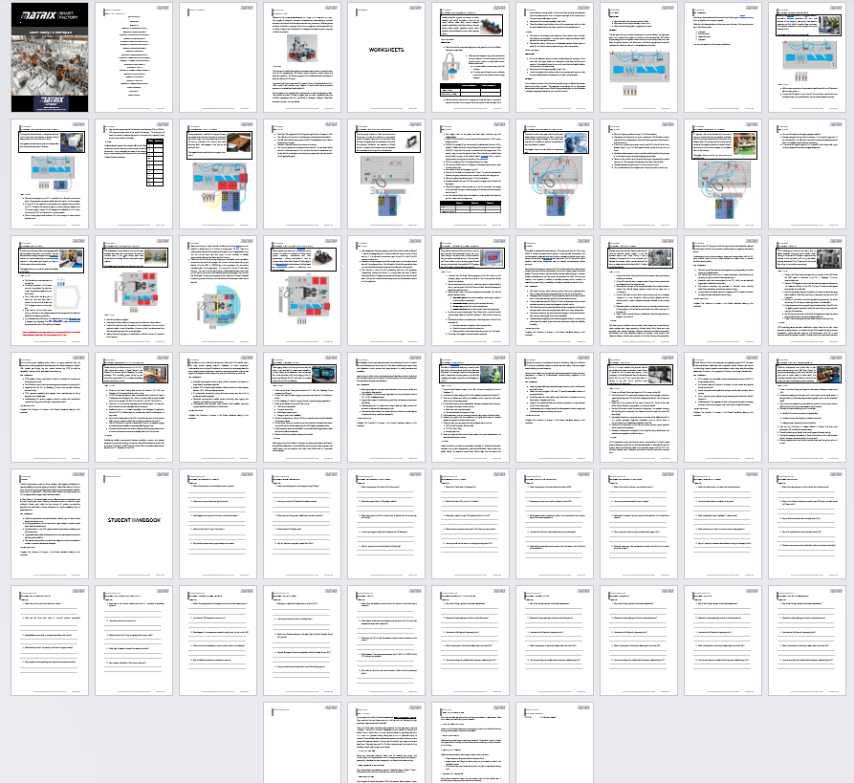

Updated Front Cover
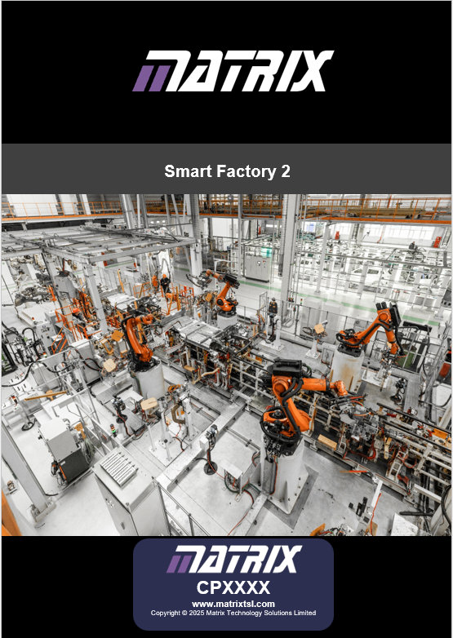

Worksheets
Smart Factory 2 worksheets will be;
Worksheet 1 – Understanding Sensors
Worksheet 2 – Reject Mechanisms
Worksheet 3 – Understanding the Conveyor
Worksheet 4 – Sorting Counters
Worksheet 5 – Driving the Stepper Motor
Worksheet 6 – Understanding the Plunger
Worksheet 7 – Delivering Counters
Worksheet 8 – Robot Arm
Worksheet 9 – Commissioning the Cell
Worksheet 10 – Completing the Smart Factory
Worksheet 11 – Defects & Reset Sequence
Worksheet 12 – Vision System
Worksheet 13 – RFID
Worksheet 14 – Network & Communications
Worksheet 15 – Data Logging
Worksheet 16 – Analytics
Worksheet 17 – IO-Link
Worksheet 18 – Predictive Maintenance

Electrical Drawings First Draft
First draft is completed, I need to look into creating all the sub assembly wiring plan for each sub assembly.
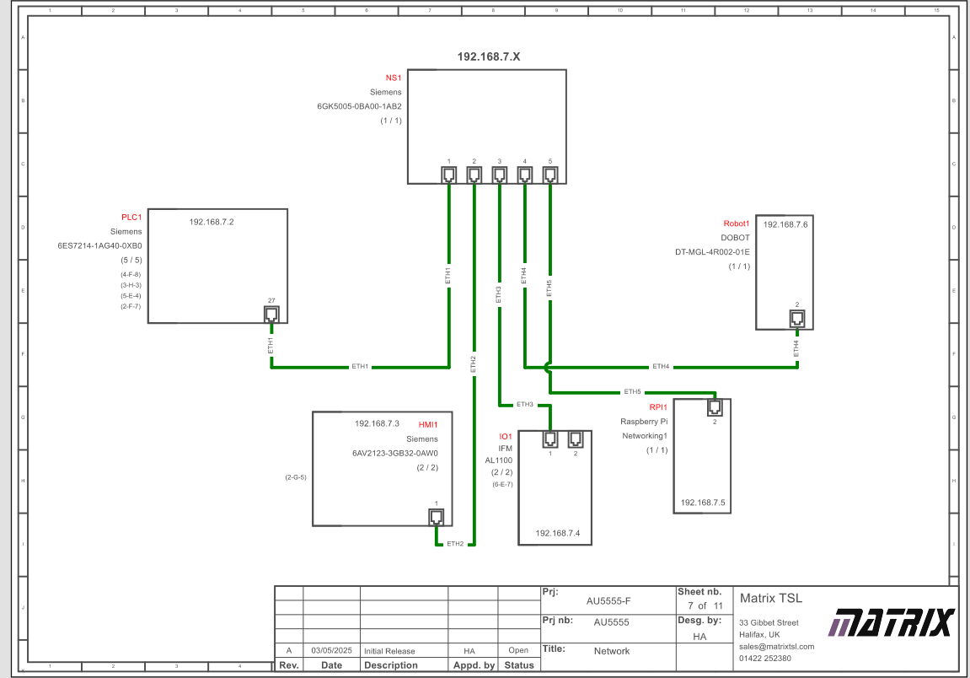
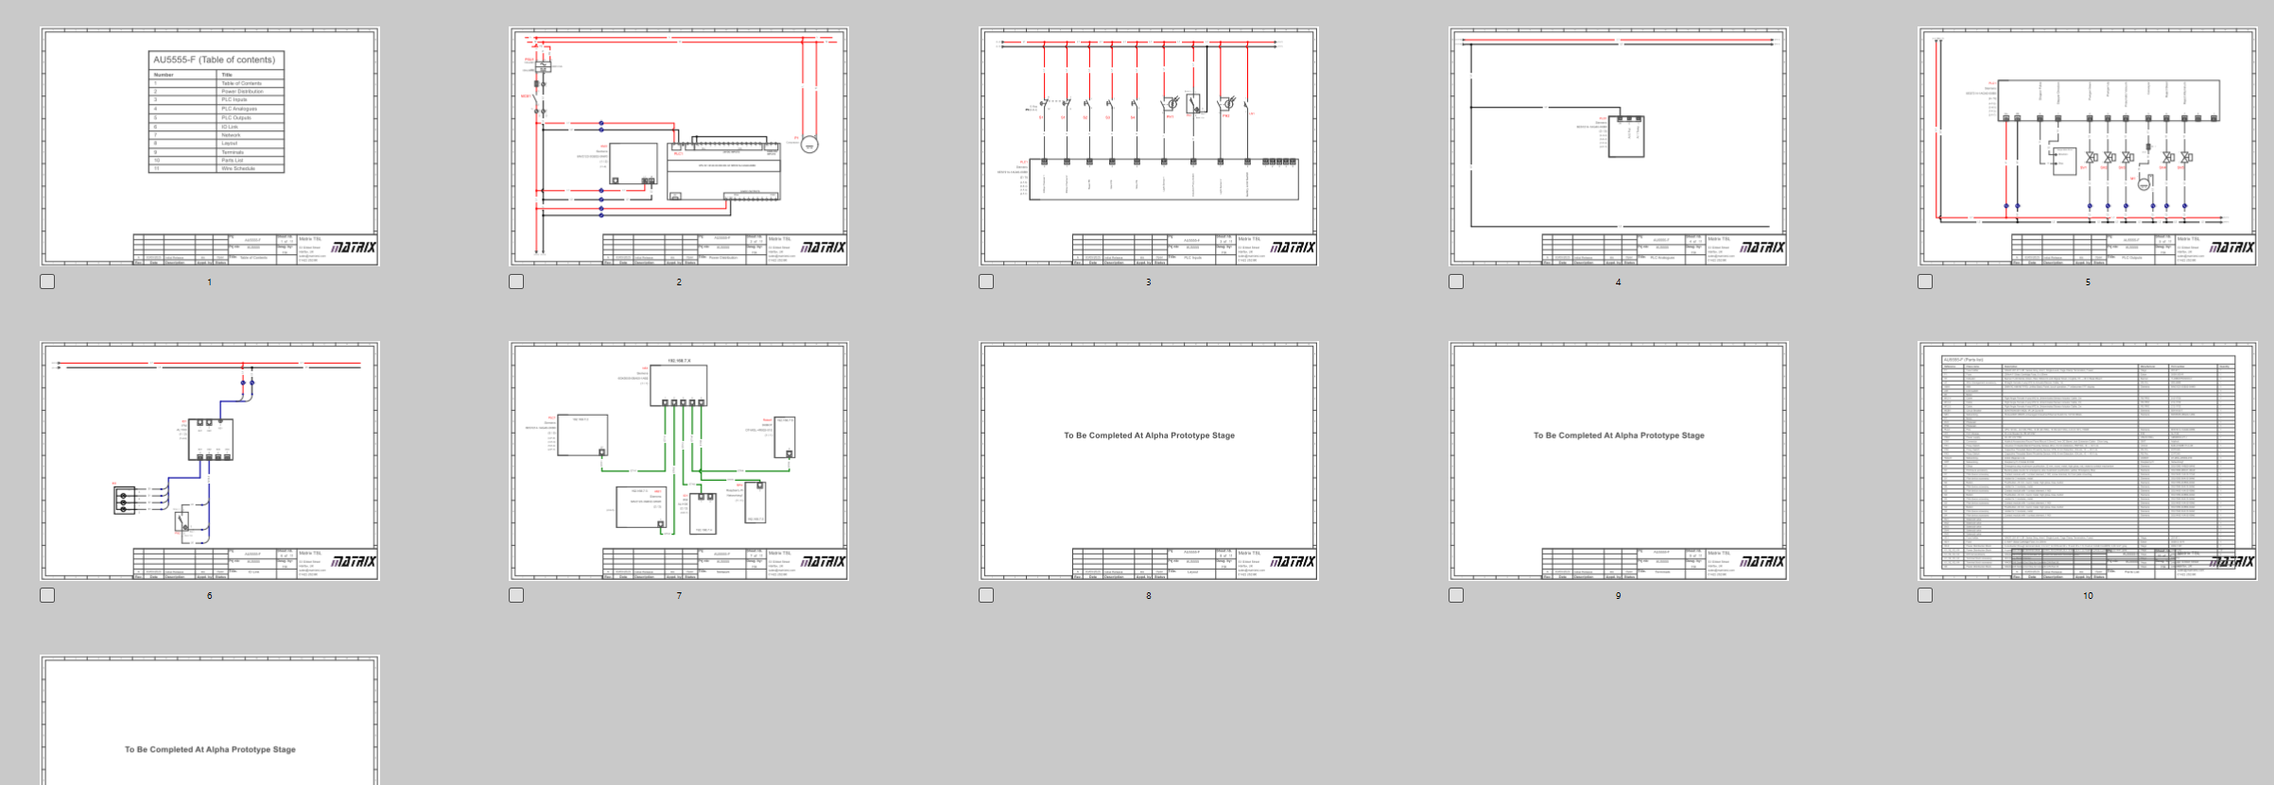

PLC Software
I’m currently rewriting the software from scratch.
What I’ve done so far;
- Status LED Code
- Faults Code

Still to do;
- Start Conveyor/Sequence
- Camera defect detection
- Reject cylinder fire
- HMI 7inch Template From IM

Main Sequence
The green start button latches the start command which, dumps the counters into the hopper by driving the linear actuator relay, runs the conveyor until the photoelectric sensor is triggered, the PLC then sends the command to the camera to start.
The PLC then waits to see if an object has been detected, if a defect has been detected or if the camera errors out.
If it's a defect , it fires the cylinder reject pin. If the object is ok then the PLC calls the gantry to come get the object.
The gantry then takes the object to the second conveyor. Placing the object on the gantry triggers the 2nd photoelectric sensor. Once the gantry has returned back to it's position, the second conveyor starts and awaits the trigger of either of the proximity or capacitive proxy's. Then the conveyor keeps running until the 3rd photoelectric sensor is triggered. At which point the conveyor stops and the robot arm grabs the object and correctly sorts it into the sorting bay.

Digital Curriculum
Started a mobile app

State Machine
State | Name / Function | Next State | Triggering Condition
0 | Reset / Idle | 1 | Green Start Button + Safety OK
1 | Dump Hopper | 2 | 2-second Off-Delay timer finishes
2 | Gantry Positioning (Pos 1) | 3 | Gantry at Pos 1 + 1s Delay
3 | Activate Vacuum | 4 | 2-second Delay
4 | Pickup Cube | 5 | 1-second Delay
5 | Move Gantry (Pos 2) | 6 | Gantry reaches Position 2
6 | Drop Cube | 7 | Vacuum Reset + Plunger Up
7 | Wait for Robot | 8 | Light Sensor 3 Triggered
8 | Reset Delay | 1 | 5-second Timer

State 0: Reset / Idle
- Purpose: Initial safety state and system clear.
- Activation: Occurs on startup, if Safety_OK is lost, or if #enable is lost for 3 seconds.
- Actions: Resets all internal flags (#cube_at_lightsensor1, cube_dropped, #enable) and turns off all outputs (Plungers, Vacuum).
- Transition: Moves to State 1 when the Green Start Button is pressed and Safety_OK is true.
State 1: Dump Hopper
- Purpose: Prepares the hopper and initial gantry position.
- Actions: Sets #enable, activates the Linear Actuator for 15s, and moves the gantry to 50.0.
- Transition: Moves to State 2 after a 2-second off-delay timer.
State 2: Gantry Positioning (Position 1)
- Purpose: Aligns the gantry for pick-up.
- Actions: Moves Gantry to Position1 (10.0).
- Transition: Moves to State 3 once the gantry is not busy, the light sensor is clear, and the 1-second delay is complete.
State 3: Activate Vacuum
- Purpose: Engages the suction before lifting.
- Actions: Sets Pneumatic Vacuum (Q0.4).
- Transition: Moves to State 4 after a 2-second delay to ensure vacuum seal.
State 4: Pickup Cube
- Purpose: Lifts the cube from the first location.
- Actions: Sets Plunger Up (Q0.3), resets Plunger Down (Q0.2), and sets Gantry.Busy.
- Transition: Moves to State 5 after a 1-second lift delay.
State 5: Move Gantry (Position 2)
- Purpose: Transports the cube to the second conveyor.
- Actions: Moves Gantry to Position2 (250.0).
- Transition: Moves to State 6 once the Current_Position equals 250.0.
State 6: Drop Cube
- Purpose: Releases the cube onto the second conveyor.
- Actions: Lowers the plunger (1s), turns off the vacuum (1s), then raises the plunger and sets the #cube_dropped flag.
- Transition: Moves to State 7 once the drop sequence and plunger retract are complete.
State 7: Waiting for Robot
- Purpose: Handshake with the next stage of the process.
- Actions: Monitors Light Sensor 3 (IN7).
- Transition: Moves to State 8 once the sensor detects the robot has picked the item.
State 8: Reset Delay
- Purpose: Cooldown period before the next cycle.
- Actions: Starts a 5-second timer.
- Transition: Moves back to State 1 to begin a new cycle.

Alpha Review
Bring the following..

- Updated progression numbers
- IO-Link Demo
  - Startup Purple
  - Green Healthy
  - Red Error
  - Amber Flash Camera Busy
  - Amber Defect Detected
  - Green Flash On Startup
  - Purple Flash waiting for Robot
- List of Faults programmed

New

